18th meeting of the
Faculty Student Council of Law
Date |  | February 3rd 2026 13:00 – 15:00 |  |  | Location | Nieuwe Achtergracht 166, REC A,
Present |  |  |  |  | Absent
Guest  Online |  |  |  |  | Secretary | Anouchka van Wier

Agenda
Notes by the chair are written in cursive and are part of the agenda and the minutes, after publication.

- Opening of the meeting
- Setting the agenda
- Last Action-List
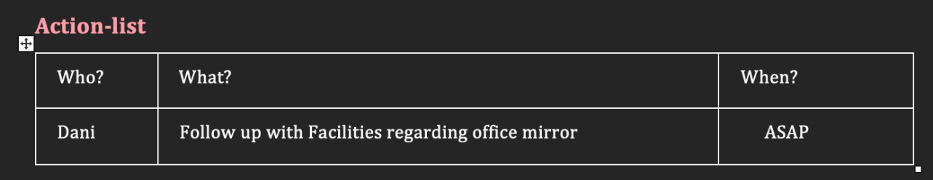
Dani: Facility services said that they cannot hang up a mirror but they can hang up a painting. Furthermore, we will get new sofas in March.
- Glasgow – Livni
  - Livni: sent the brochure into the signal group and asked whether there are questions.
  - Carla: Is there an alternative program for if it rains and or people cannot hike.
  - Livni: Currently not but he will come up with something.
  - Noor: If the distillery is part of the group trip, do people need to go that are not drinking/ do not want to do that?
  - Livni: people can also eventually go in their free time to the distillery and we will do something together.
  - Dani: I am a big fan of the planning.
  - Carla: Any other points, considering that it is this Friday?
  - IF people want to give things into a big suitcase or want a designated seat on the plane reach out to Livni.
  - Carla: are we making it mandatory to bring the hoodies?
  - Livni: that was the idea.
  - Vince: Is breakfast included?
  - Livni: not included
  - Noor: is the clubbing included?
  - Livni: idea was that we can do something together.
  - Idea: we could also go to a pub and then go to the club (we will decide on Friday).
  - Activity ideas:
    - Karting
    - Distillery
    - Other ideas: let Livni know.
- Use of American software – Dani
  - Dani: sent a meeting piece. It is about reliance on U.S. software. Example: ICC software.
  - Carla: the point raised: should we rely on U.S. software due to the current situations. Just U.S.?
  - Dani: Would be interested to know generally what / who´s software we are using.
  - Livni: Asking which software is used is a valid question to ask. Fabian raised a point: is it better to ask it also on central level?
  - Dani: good point, but we thought we would start here as well and then see.
  - Noor: Good point to also raise it on central level. Note: our dean is an expert on IT law so she is probably quite knowledgeable in that field so it could be a very constructive conversation.
  - Vincent: Valid question to ask. There is a digital learning environment board and they discuss those topics. For the CSR Vincent was joining the meeting. All faculties are using the same engine so maybe we should ask it at central level since the faculty most likely will give the same answer (that they get it from central level).
  - Carla: Is this something we should send an email or bring up at GOV.
  - Livni: we can do both.
  - Carla: we will send and email to Candida.
- Updates
  - CSR
    - Vincent: not too much happening currently but there is a new CVB chair coming. A meeting with him went well. Half the CSR wants to abstain in the advice due to being kept out of the procedure. The advise given will not have an effect since it is a formality. The other part is not agreeing on abstention but it will be reflected and discussed in the next weeks PV.
  - O&O
    - Noor: this week we have the Q/A session for Bachelors, Masters, and PPLE. There was a meeting with Claudia where points have been discussed already and lowers the amount of points to ask in the upcoming meeting. Hardship clause question has still to be discussed and we will not give positive feedback unless there is more leniency. So we want to ask how much discretion there currently is since there are some unclarities. Discretions seem to be clear in most of the other situations but not with the hardship clause.
    - Carla: in the pre-meeting yesterday we wanted to discuss the exam inspection possibility and were told that this is less successful in the GOV but should go through the program directors.
    - Noor: is this for the entire faculty including PPLE?
    - Carla: just a heads up that Mireille agreed to send a reminder to the program directors. Candida and Carla will sit together with chairs of PC to look into how we could increase the student feedback/ course evaluation.
    - Livni: somebody from private law reached out and that person said that lectures are not being published and that person wanted to know whether we could ask the course director if they could do so. There is no right but it is general practice so it could be interesting to discuss it.
    - Noor: where any reasons given?
    - Livni: not sure, at least no known reason has been provided.
    - Noor: I will look into it.
  - O&F
    - Johannes: we have the event today, please all come. After that we will plan everything for the second semester at evaluation weekend.
- Other points/question
  - Dani: Fabian asked whether we already have a weekend for transition weekend.
  - Carla: we already set one, first weekend of July (3rd to 5th).
- Closing the meeting
  - Closed the meeting at 13:50

In the case of absence and/or mandate, please send an e-mail to livni.fsr.fdr@gmail.com.

Action-list
Who? | What? | When?
Everyone | Bring FSR Hoodies | Friday (lol)
Carla | Send an email to Candida regarding Danis meeting piece | In due time
Noor: | I will

