23rd meeting of the
Faculty Student Council of Law
Date |  | March 17th 2026 13:00 – 15:00 |  |  | Location | Nieuwe Achtergracht 166, REC A,
Present |  |  |  |  | Absent
Guest  Online |  |  |  |  | Secretary | Anouchka van Wier

Agenda
Notes by the chair are written in cursive and are part of the agenda and the minutes, after publication.

- Opening of the meeting
- Setting the agenda
- Last Action List
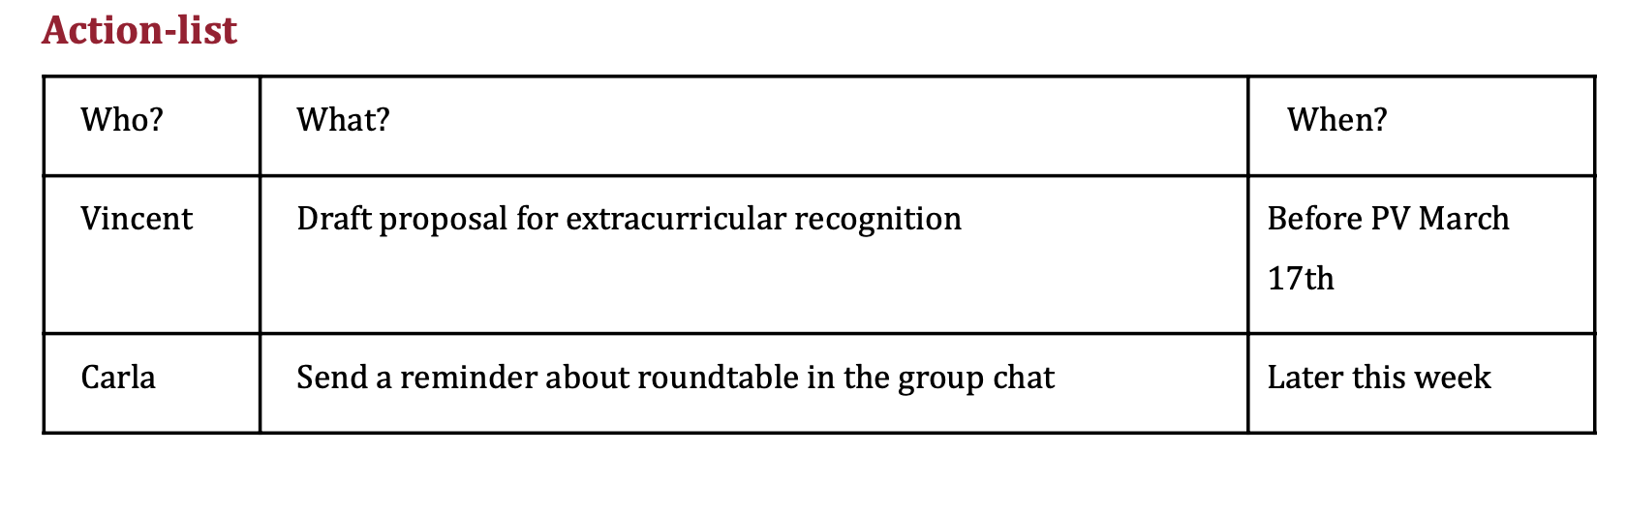
- AI survey
  - Johannes will translate the survey and will then share it.
- AI Round Table:
  - Noor: Faculty explained how they have implemented and adapted AI. They also shared fears (?)
  - Fabian: they seem a bit hesitant and might underestimate the capabilities of AI. Meeting was not super useful but rather an exchange.
  - Noor: they are also currently not really allowed to use AI and that is also their general take.
  - Carla: any take-aways?
  - Noor: might be useful when working in the Court – not just when working at a law-firm.
  - Carla: anything that we should bring to the next one (with the OCs – Bachelor Law).
  - Noor: change of assessment / examination might be interesting to discuss.
- Formal Recognition extracurricular activities students – meeting piece
  - Vince: summarized meeting piece
  - Carla: Any amendments?
  - Noor: what about internships (e.g., PPLE can give 6 ECs for an internship).
  - Vince: internships will not be included since students can either get credits for it and therefore get the recognition.
  - Dani: More recognition would follow if we tell university to invest more into these initiatives (e.g., Law Hub, and other initiatives).
  - Vince: good idea, I also think that we can do it in several steps.
  - Dani: I understand, I just think that we might be able to achieve more if we also look at the funding.
  - Vince: yes but this is not the point that we are currently discussing.
  - Fabian: we can maybe divide it into two points (funding versus recognition=
  - Dani: I think it does not make too much sense.
  - Carla: Would it be an alternative when we submit it and also then look at increasing the funds for those initiatives.
  - Dani: I think that it might have a negative effect, especially adding work pressure which is a tricky topic, especially when looking at not so privileged students.
  - There are different arguments brought forward by Vince, Noor, and Dani.
  - Carla: I think we are not yet at a point where we agree on something.
  - Noor: maybe we can look how this translates into the Dutch system (white paper).
  - Vicne: yes that is a good addition, and also in paragraph 3 of the meeting piece and will be further added (white paper).
  - Carla: should we do a temperature check.
    - Temperature check out come: more discussion needed.
  - Dani: Recognition is something that students deserve. I do think that some study associations are already recognized.
  - Fabian: yes, the point is also that you can do meaningful work in a smaller association.
  - Carla: also, study associations are in that sense quite Dutch meaning that if people want to go abroad they will not get that recognition.
  - Carla: raises point that recognition problem might not be solved but also not make it worse?
  - Noor: the arguments could go both ways regarding efficiency.
  - Fabian: the UvA will implement it differently since usually there are different talks before such an initiative will be implemented, but it would be interesting to see if the UvA is open to even do it?
  - Carla: The question now is also whether sending this would hinder the goal of also not increasing study stress
  - Dani: would be great if both works. Raises a concern that people will apply for positions and then free-ride which would not only take away spots from motivated students but also decreases then the efficiency of the associations.
  - Anastacia: explains how it works in the Bachelors.
  - Noor: maybe we can bring in amendments that reflect also on privileged students.
  - Carla: could we add to the meeting piece that the current draft is the first step and then add the second point of helping students that could otherwise not afford that.
  - Vince: I agree with it but if we put too many things on it, it could hinder the process, but not right now. Also, there is this meeting piece here and if we do not pass that.
  - Dani: I am not sure what would pass in the university but ultimately there should be more money for the student initiatives.
  - Vince: your point is valid but not in the scope of this meeting piece.
    - 5 minutes of break
  - Carla: has anyone a new proposal
  - Dani: I did come up with an amendment since I like the content but maybe there is a different solution:
    - Have a template about the student/ what they did. This will then get stamped by the UvA and you can additionally upload it. It will not be on your diploma but you still have an additional document.
  - Vince: this is in essence what the meeting piece is saying, the diploma solution was just one of the options.
  - Carla: is this solution okay?
  - Vince: yes, in the CSR we usually do not want to tell them how to implement it but it would work.
  - Fabian: question to Dani: how would this be more effective than the appendix?
  - Vince: meeting paragraph sub 3: would this be separate from what is suggested.
  - Fabian: the form does not matter to me too much but I was just wondering what solution would be the most just outcome.
  - Dani: I think it would be better for students if it is in an extra document. The extra stamp might be something that students want, also in light of the purpose of this meeting piece. It might be more accessible for students that might take longer for finishing their studies Recognition comes earlier since it might come earlier.
  - Carla: is this against the point of putting it into the proposal?
  - Fabian: not it is not against it, just more about understanding each other.
  - Anastacia: One question: the diploma at the end of the course always will not weigh the same because of the honors group. There are some students with a “stronger” diploma but not all students might not be able to study that much to study for the honors group it would be nice to even that out.
  - Noor: it would be nice to also put this into the meeting piece.
  - Dani: also other universities try to reduce the working pressure.
  - Fabian: the BSA changes might be one of those actions.
  - Points raised about leveling the playing field.
  - Anastacia: for the people that are doing honors: it would be beneficial.
  - Noor added two amendments.
    - Mentioneing of the whitepapers
    - That this levels the playing field for people that are not doing honors.
  - Danis amendment:
    - UvA template about the individual students which will get checked by the university.
  - Vince: we can discuss Danis point and the form later?
  - Fabian: we can say that we want recognition but the question of how will be discussed laster
  - Dani: so we will remove the suggestions of how this will be done entirely?
  - Vote: 12 in favour.
  - Vince: I will have the draft on Friday. Caral will receive it on Friday evening the latest.
- potential conversation about communication of changes
  - Noor: it would be nice if the board would communicate more with us on faculty decision (e.g., the appointment of the new dean which caused unease with students). Therefore it would be nice to sit down with them to discuss a new communications procedure when it comes to faculty decisions such as the programme directors or dean appointments etc.. Therefore the suggestion is to send an unsolicited advice.
  - Vince: clarified whether we had advise or not.
  - Noor: the point is also that there is just such a short notice.
  - Vince: same problem in the CSR.
  - Fabain: also it is a problem for us but especially for the main student body. It is the same with the new ALF coordinator who has been appointed. Students should be in the loop. Same for the thesis changes.
  - Johannes: maybe we can have a meeting piece about constructive suggestions.
- Updates
  - CSR
    - Vince: Busy weeks. UvA is looking for a new Rector and CSR wants to be involved. UvA will include them earlier this time when it comes to advise.
    - Vince: the letter will be sent/ has been sent but procedural discussion need to go on.
    - Vince: also about UvA withdrawing about the horizon project there are debates about a letter that has been sent.
      - Dani: can you tell us a bit more about that.
      - Vince: The CvB made commitment on keeping us updated. They told us they were looking into exiting this agreement but it is legally close to impossible and financially impossible. But they are looking into various ways. The CSR letter is to remind the CvB to keep the CSR in the loop (unsolicited advise will be sent).
    - Vince: discussion about Israeli students due to the recent attacks.
      - Dani: what is the current CSR debate on this?
      - Vince: there are reports about this in the CSR PV email. But it is also about getting support for students who experienced antisemitism.
    - Vince: I have an UKO meeting at 15:00 in the Magdenhuis about general direction of education. Student well-being and academic freedom will be discussed.
    - Vince: Bring your own devise file has been paused due to privacy concerns. Some certification did ISO (?) did not get accepted. We will give an opinion to the CvB about how to react to it.
    - Vince: working on implementing the new budget/ update it which will be done every quarter.
  - O&O
    - Noor: we are currently waiting for the finalized OER which should come out this week. The rest has been discussed.
  - O&F
    - Alexandra: we have a suggested date for the Fifa Tournament:
      - 4. – 8. Of May.
      - Suggestion: 7. Or 8. of May.
      - Fabian: I can supply 2 X-box controllers. Livni maybe 2-4.
      - Johannes: I can also supply an Ps4 and two controllers.
    - Alexandra: wit the charity run: we have not yet reached out to the other faculties but its int the works.
  - Anastacia: I have asked Vince to put it on the CSR agenda.
  - Vince: We hope that we will get it within 2 weeks but usually it goes rather slow.
  - Alexandra: website regarding book-fair for students we will have a meeting on Thursday with someone from the GreenOffice.
- Other points/questions
  - Fabian: apparently there are talks about the FSR funds and they might be tied to attendance, meaning that lower attendance might lead to lower pay (instead of our current fixed amount). Hollando does not know yet and we do not know at what stage the UvA is here.
- Closing the meeting
  - Closed the meeting at 14:25

In the case of absence and/or mandate, please send an e-mail to livni.fsr.fdr@gmail.com.

Action-list
Who? | What? | When?
Everyone | Share the AI survey on social media & WhatsApp groups. | ASAP
Everyone? | Gather topics for the AI round table | Next PV .
Noor | Write communication proposal | April 1

