26th meeting of the
Faculty Student Council of Law
Date |  | April 22nd 2026 10:00 – 12:00 |  |  | Location | Nieuwe Achtergracht 166, REC A,
Present |  | Danial Haider, Johannes Hüttner, Alexandra Jurasova, Tom Scheer, Vincent Nap, Anastacia Piersma |  |  | Absent | Carla Gesell, Fabian Que, Wytze  Adriaanse, Livni Beck, Angie-Lee Kruize,  Eleonora van Koppen
Guest  Online |  |  |  |  | Secretary | Anouchka van Wier

Agenda
Notes by the chair are written in cursive and are part of the agenda and the minutes, after publication.

- Opening of the meeting
10:05
- Setting the agenda
- Last Action List
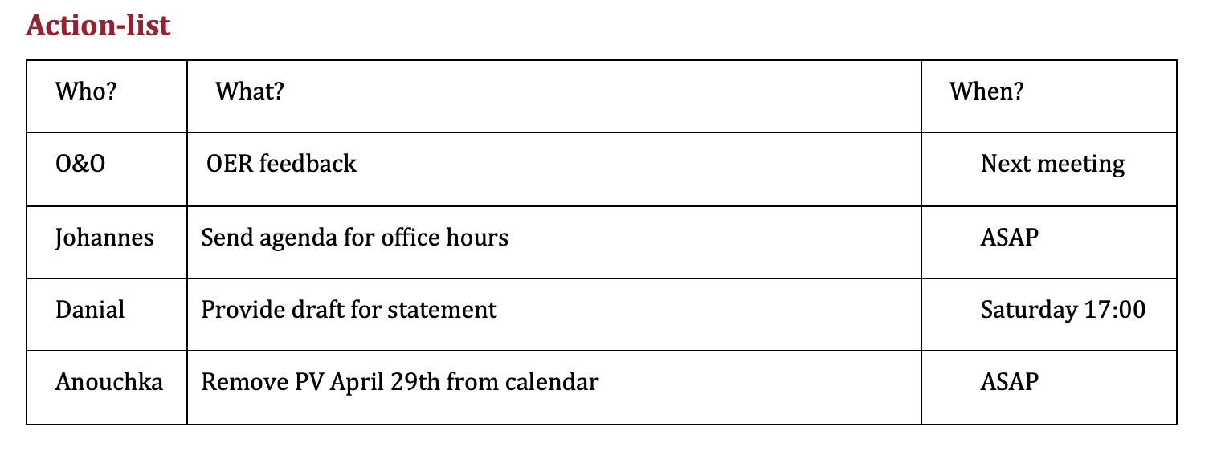
Johannes will reach out to Noor regarding pending items.
Johannes will send the agenda for office hours later today.
- Charity Run
Serve the City has been chosen as the charity. A when2meet has been sent to other councils to coordinate participation. Once feedback from other councils is received, formal invitations for sponsorships will be distributed. The event is scheduled for early June (but will have to wait on specific date).
- GOV agenda
  - Formal Recognition extracurricular activities students – meeting piece
Vincent will send a request for a meeting to Nanda and Marco today.
  - Information on militarization
Mireille has noted that all information regarding defense cooperation is public. A new cybersecurity lecturer is being appointed. Johannes (current student of master in Public international law) observed that current education maintains an objective legal standpoint on militarization. The other course on military cooperation is often followed by military personnel, he noted it was positive that military personnel receive legal training.
Vincent said that discussions will be held at CSR this week, the student council will revisit the topic once central updates are available.
- The Dutch Government must comply with and enforce international law – meeting piece
The agreed timeline:
- Tom and Danial will share the Google Doc for comments and feedback later today
- May 2: Deadline for council members to provide feedback
- May 5: After incorporating feedback, final version will be distributed to the council
- May 6: Formal vote during the PV
- May 7: Possible feedback will be incorporated again
- May 8: Goal is to post it on this day
- Updates
  - CSR
Vincent is working on Q1 overview of budget, later today during their meeting the militarization debate will be discussed. As well as discussion regarding activism at AMC. The selection process for the new student assessor has been successfully concluded. The new procedure for providing unsolicited advice is set to be presented. Additionally, a town hall meeting for all o&o will be held about OER adjustments.
- Danial asked what the activism on AMC entails, Vincent said today was information session and referred Danial to the meeting piece of CSR that was sent to FSR a few days ago.
  - O&O
No specific updates
  - O&F
Primary focus is currently the Charity Run planning. A committee meeting is scheduled for after this PV.
- Other points/questions
Anastacia inquired about the exact date for the Charity Run. It was clarified that the date will be finalized following the when2meet responses.
- Closing the meeting
10:40

In the case of absence and/or mandate, please send an e-mail to livni.fsr.fdr@gmail.com.
Action-list
Who? | What? | When?
Johannes | Contact Noor on OER feedback | Today
Johannes | Send agenda for office hours | Today
Vincent | Email Nanda & Marco regarding extracurriculars | Today
Tom & Danial | Share draft of statement | Today
Vincent | Report back on CSR militarization discussion | ASAP
Everyone | Provide feedback on statement | May 2nd
Tom & Danial | Final version of statement | May 5th

